ADIDAS SUPERSTAR CONCERT

There are projects you never forget. Transforming an entire stadium into a giant shoebox and crafting all the visuals for The Sound of Superstar(s) concert by adidas is definitely one of them. On September 18, the adidas Arena in Paris became a true temple where music and fashion came together under one symbol: the legendary adidas Superstar.

For Ubi, our team designed and produced hundreds of assets, from stadium wraps and interior decor to invitations, tickets, stickers, badges, signage, goodies, menus, and more. We also created some of the event’s video projections and digital content for the campaign leading up to the concert. A project with this kind of scale and energy is one to remember. 🔥

Project lead & credits: Ubi
Pictures: https://saranistudio.sharepoint.com/:f:/s/SaraniAssets/IgCvTW5-VHvORq-gAO8K7ZXkATNBxy2yfL0a-qFXYP_XOJg?e=Drwn7a

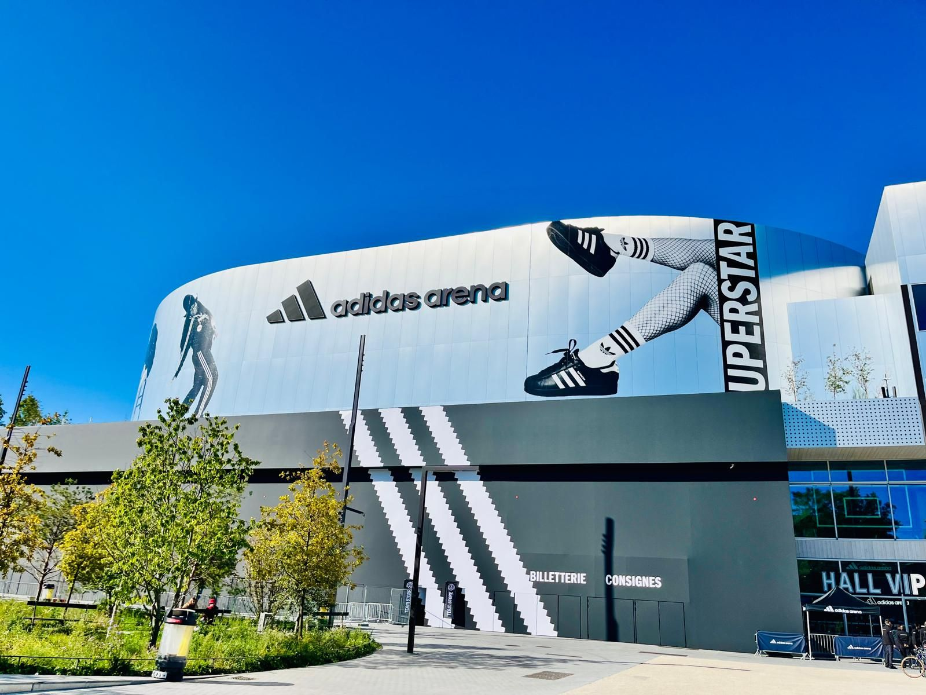

ADIDAS WORLD ATHLETICS CHAMPIONSHIPS

In September 2025, the World Athletics Championships took place in Tokyo. Each French athlete received their jersey in a special cool box sent by adidas. A project brought to life by our Sarani team, spread all around the world 🌎

- Bento box design created in France, in the colors of the French team
- Stickers and keychains hand-drawn in Argentina
- Championship program designed in Canada
- Origami crafted in the United Arab Emirates
- Print files produced in Croatia
- Project management handled from France & Colombia
A truly global effort!
Project owner: Ubi
Pictures: https://saranistudio.sharepoint.com/:f:/s/SaraniAssets/IgCVmIFAQhvUSpfbdcW3qXEcATbanR1SoOI0w0nQQtjIocA?e=kjavIh

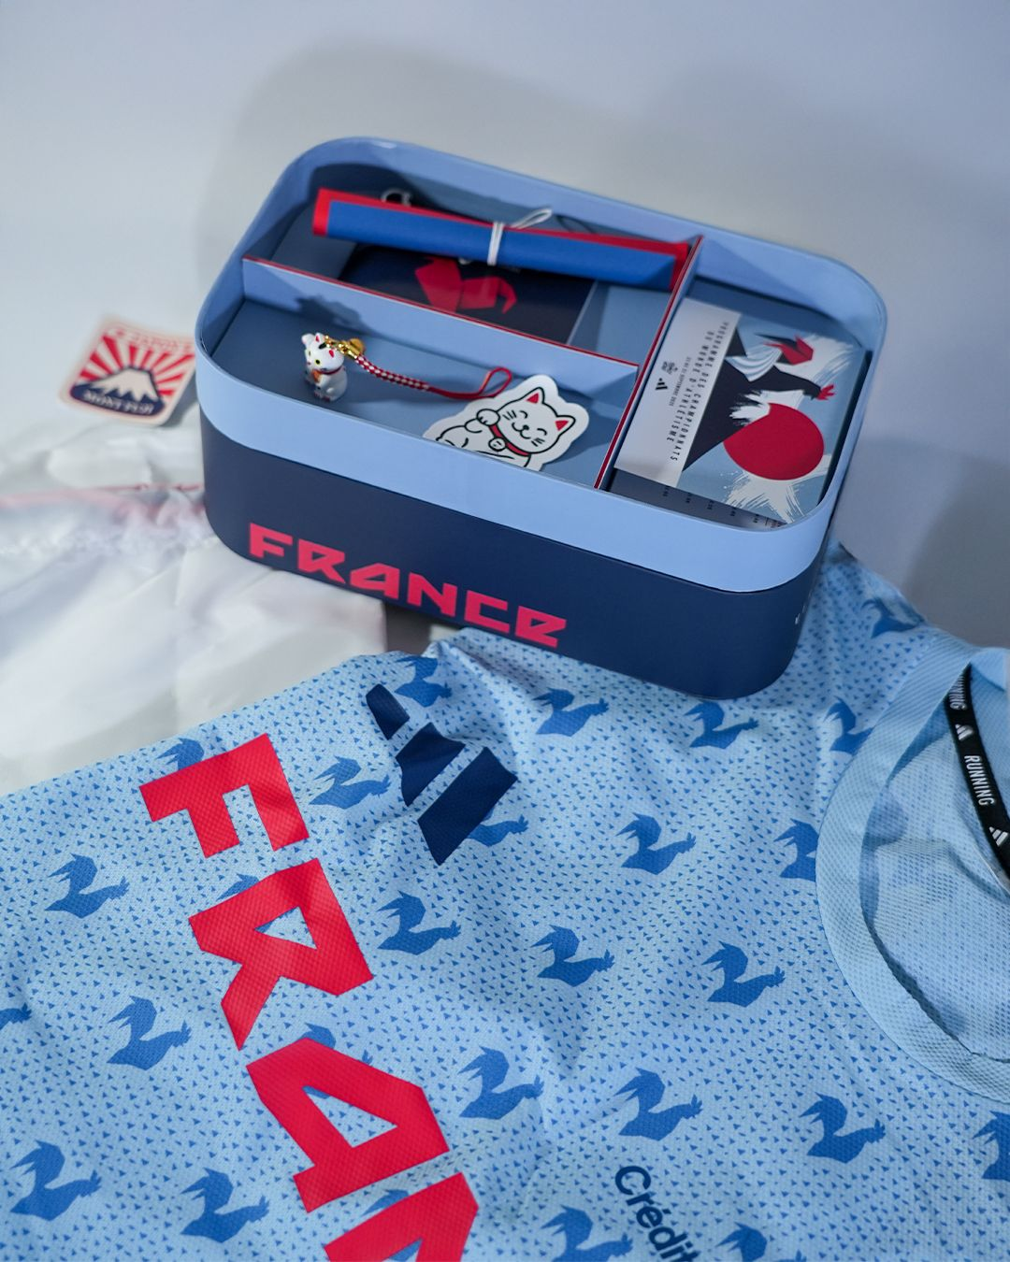

IKEA SUMMER TOUR

When IKEA hits the road, we roll with them. 🚚
This summer, the IKEA Summer Tour stopped in 8 cities across France, bringing a mobile design workshop directly to people on vacation, from the seaside to the city.
For this project, we brought the creative concept to life through the production and execution of all visual assets: from the truck’s design and setup, to promotional materials for the pre-tour campaign, and video content displayed inside the mobile workshop.
A vibrant, hands-on project that showcased our know-how and helped carry IKEA’s design spirit across France.
Project lead: Ubi
Pictures: https://saranistudio.sharepoint.com/:f:/s/SaraniAssets/IgCFGfc3UWsIQI1hSiDCD2foAWBg2fWafd49tqLYbW4XzVo?e=NeT1of
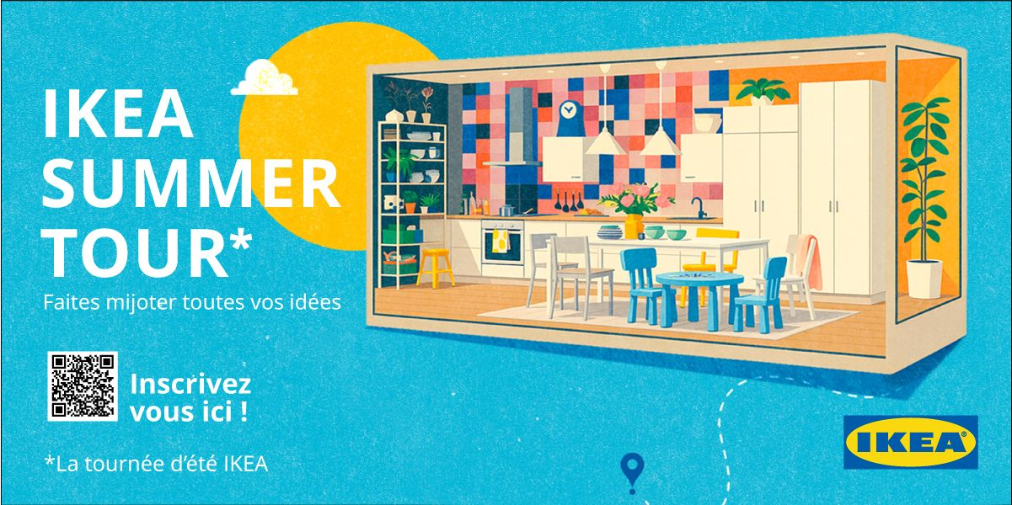

IKEA BILLYOTHÈQUE

Our first collaboration with IKEA under the Parisian summer sky. ☀️
For the BILLYothèque, the open-air library set up along the Seine in partnership with Bibliothèques Sans Frontières, IKEA celebrated its iconic BILLY bookcase with a unique, larger-than-life experience. Our team brought the event to life through the production of print and digital assets: banners, winning tickets, structure branding, and promotional materials used on-site and online.
A creative, meaningful project combining design, culture, and accessibility, right at the heart of Paris.
Project lead: Ubi
Pictures : https://saranistudio.sharepoint.com/:f:/s/SaraniAssets/IgAHuCct4-_nQLuCWoJM_ignAQ6EGvMpKyD16WUG8_iyWMA?e=NSnpaS

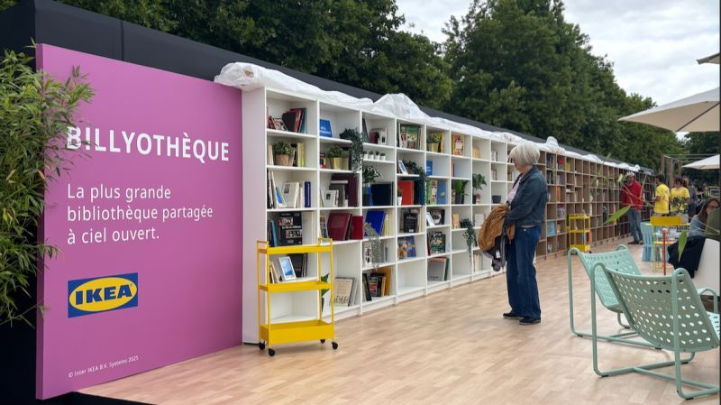

ADIDAS 10K PARIS RACE

On Sunday, June 8 2025, the adidas 10K Paris brought thousands of runners together for a scenic 10-kilometre route through the heart of the city.
For this iconic event, Sarani supported the experience by executing the key visual and branded assets that made the race feel immersive and alive, from designing the store space for bib collection, to creating the official race calendar and posters, developing event goodies, and producing signage and branded elements for both the race village and the closing-night celebration.
It’s always gratifying to see runners cross that finish line and to know our designs were part of the journey.

Project lead: Ubi
Pictures : https://saranistudio.sharepoint.com/:f:/s/SaraniAssets/IgA1-tdzmA9lQ4A1lFBiCnvTAfTKlvhIaPOb08XCCvgRCA0?e=k36ITD
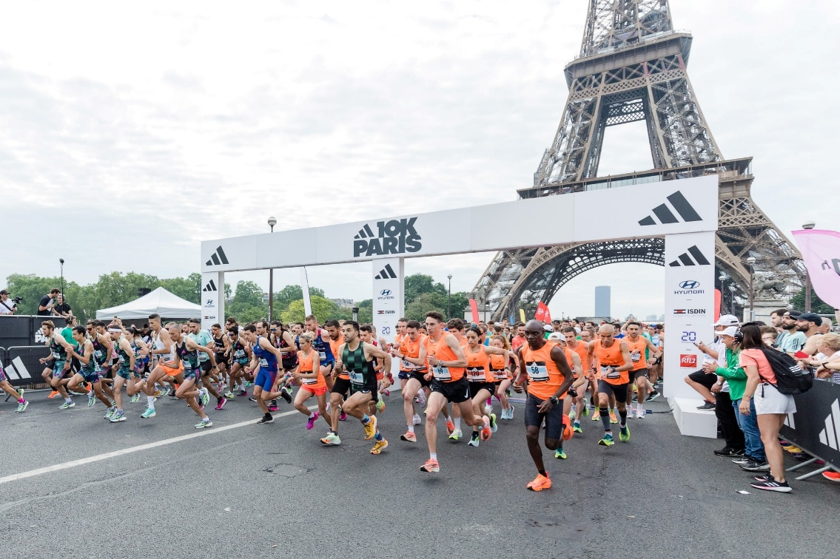

LEGO – LE GRAND TOURNOI DES CHAMPS

On 21 September 2025, the Avenue des Champs‑Élysées transformed into a giant playground for the “Grand Tournoi des Champs” LEGO®. More than 250 teams gathered from families to friends, taking on creative construction challenges under the open sky of Paris.

For this one-of-a-kind event, our team helped bring the experience to life: from the main event poster to the print and digital campaign, scenography, and screen content broadcast during the competition. We also designed the web platform and crafted a range of branded elements that gave the tournament its playful, immersive atmosphere.
A colorful, joyful project that turned the world’s most famous avenue into a celebration of creativity and a moment we’re proud to have helped build.

Project lead: Ubi
Pictures : https://saranistudio.sharepoint.com/:f:/s/SaraniAssets/IgCdzmRij4M0Q41Orfzf1obLARiM-TLNX01IJfWcPt0UXfk?e=f03pcD
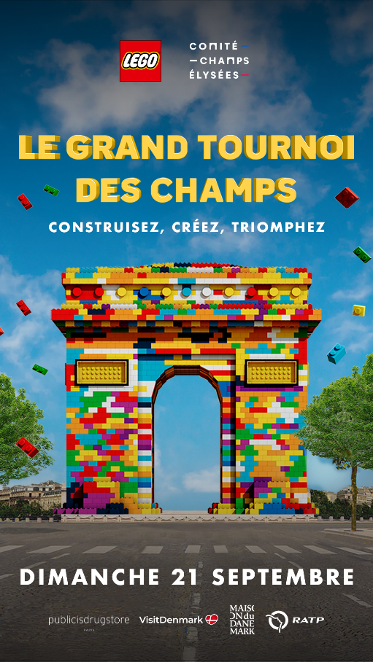

IKEA COOKING SESSIONS
From September 12 to 14 2025, during Paris Design Week, IKEA transformed the Place de la Fontaine aux Lions in Paris into a vibrant festival of food, design and music, with a bold scenography imagined by Uchronia.
Sarani brought this concept to life by creating the key visual, handling the branding of the scenographic elements - including the main stage and cooking stations - and designing the recipe materials, along with digital and print visuals for the communication campaign.
A creative and collaborative project that combined culinary experience, design, and visual storytelling, proudly executed alongside IKEA, CTRL+ and Uchronia!
Project lead: Ubi
Pictures : https://saranistudio.sharepoint.com/:f:/s/SaraniAssets/IgAoDI6811RmTaRYUcuRRlg_AXyDQSWLZy0-M_e0bs54DIQ?e=baI8RZ
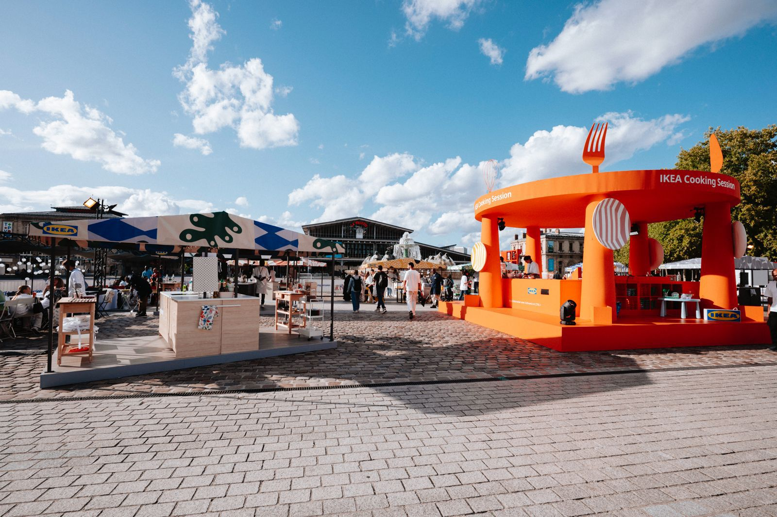

AIR CORSICA ROUTE LAUNCHES — MUNICH & VIENNA
We were thrilled to support Air Corsica for the launch of two new routes linking Corsica with Munich and Vienna. For this campaign we produced a complete suite of creative assets, from static posters to short promotional videos, and adapted every asset into the many formats required for airport screens and displays. The result: striking visuals and motion designed to capture attention in busy terminals and drive awareness for the new services.
Project lead : R-Advertising
Vidéos et photos : https://saranistudio.sharepoint.com/:f:/s/SaraniAssets/IgBv5Z9knYfFSJmtpkkkxLtNATrz_awoOQUiw1MM0-e1la4?e=gTzaea

CROCS IN TIME SQUARE

We had the pleasure of creating visuals for Crocs’ week-long takeover of TikTok Shop USA, with a twist… everything had to be sized for one of the world’s most iconic advertising stages, Times Square in New York!
The campaign featured assets adapted for massive digital displays, built to stand out amid the energy of one of the busiest screens on the planet.
This promotional week was dedicated to Crocs as part of TikTok Shop’s U.S. programming, offering exclusive deals and delivering a major brand moment in premium out-of-home media. We’re proud to have brought this high-impact campaign to life, reaching audiences in an impossible-to-miss location and blending brand creativity with digital commerce momentum.

Pictures: https://saranistudio.sharepoint.com/:f:/s/SaraniAssets/IgDCR6l4w2sRS6G0l-AfM3RtAXGFJzHiInMnrLzhk1h2rT8?e=DmGOfj

L’ORÉAL SHOW

We were thrilled to be asked to handle the signage for L’Oréal Paris’s flagship show at Paris Fashion Week 2025. From way-finding panels directing guests, staff, models and VIPs, to the design of the photocall backdrop, seat-markings, placement cards, badges and more, we delivered a comprehensive, cohesive visual system across every touchpoint. With its bold theme of “Liberté. Égalité. Sororité” and a breathtaking setting on the parvis of Hôtel de Ville de Paris, L’Oréal’s 2025 edition was more than a runway, it was a statement.
Working side-by-side with Ubi to support one of the most-visible events of the season was an honour, and we’re proud our operational work helped reflect the prestige, creativity and inclusivity at the heart of the moment.
Project Lead : Ubi
Pictures: https://saranistudio.sharepoint.com/:f:/s/SaraniAssets/IgAhFny6cJUyRq2TBXqzAyp8AUJHHtnh4F2kafkPXs4L2JU?e=pTfJWd

SONY MONTH BOULANGER

In October, to celebrate Boulanger’s month dedicated to innovation and Sony’s signature sound quality, we had the pleasure of producing a full suite of digital assets for the campaign. This included newsletters, static and animated banners, all designed to highlight the brand’s special offers and trade-in deals throughout the month.
We’re proud of the trust Sony places in us year-round, and we were delighted to help showcase the brand during this key moment in the retail calendar.

Pictures: https://saranistudio.sharepoint.com/:f:/s/SaraniAssets/IgCEyK-X-gn4RpKXxJywDU3AAWEU_mElnflFQRwB1GWVtrs?e=KkhZ03

CMC Markets
Over the past few months, we’ve had the pleasure of partnering with CMC Markets to produce a series of promotional videos showcasing the excellence of their trading tools, designed to empower traders and investors alike.
Our collaboration began with the creation of a dedicated video for Spectre, their innovative tax-efficient trading account offering multiple advantages. Using the visual metaphor of a mountaineer climbing toward the summit, the concept highlighted how Spectre helps users reach peak performance while keeping tax costs to a minimum.
Building on this first success, we went on to support CMC Markets in the production of several dynamic and modern video spots, tailored to each of their communication platforms. These assets reinforced CMC Markets’ renewed positioning as the Best Mobile Trading Platform, an accolade awarded by leading and trusted industry rating bodies.
Pictures: CMC
Crypto Owl

We recently partnered with Crypto Owl, an educational program dedicated to making the world of cryptocurrency accessible to everyone. Together, we produce engaging educational videos that break down every facet of crypto: from its origins and key technical concepts to practical guidance on how to choose where and how to invest.
Building on scripts and educational content originally developed by Crypto Owl, our role was to bring their vision to life through compelling visuals and engaging formats. By translating their expertise into clear, approachable videos, we helped transform a complex and often intimidating subject into content that feels both accessible and genuinely useful, empowering viewers to navigate the crypto space with greater confidence. The result is a series of concise, instructive assets that resonate with audiences of all ages and backgrounds, proving that with the right creative execution, even the most complex topics can become easy to understand.
We’re proud to support Crypto Owl in their mission to democratize financial knowledge and help shape a more informed generation of investors.
Images: Crypto Owl

ESPI website (we did that: Groupe-espiESPI - École Supérieure des Professions Immobilières )

